VARIETY WHOLESALER’S IMPORT MANUAL



SOFTLINES

Revision 1 07/30/18
VARIETY WHOLESALER’S SOFTLINES IMPORT MANUAL

TABLE OF CONTENTS

- Introduction
- Supplier Agreement
- Product Liability/Insurance
- Copyright/License Agreement/Release Letter/ Letter Of Release
- Indemnification Obligations
- Code of Conduct and Business Ethics
- Quote Sheet
- Letter of Credit Procedures
- Sample Approval and Lab Testing
- Price Ticket Ordering Procedure
- Price Ticket Approval Procedure
- Price Ticket Placement
- Main Labels, Hang Tags, Etc.
- Garment Hanger Program
- Carton Guidelines
- Shipping Instructions
- Vendor Chargebacks

VARIETY WHOLESALER’S SOFTLINES IMPORT MANUAL

Variety Wholesaler’s, Inc. is a leading discount retailer of quality merchandise at everyday low prices. Through convenient neighborhood locations, Variety Wholesaler’s primarily serves lower, middle and fixed income families. Variety Wholesaler’s operating structure and focused assortments allow it to offer quality merchandise with excellent value.

Variety Wholesaler’s, Inc. values our credibility and reputation with U.S. customs and other government agencies. Our efforts are directed toward maintaining and strengthening these relationships by complying with all rules and regulations.

This vendor manual is designed to increase your understanding of the requirements necessary to participate in the import program with Variety Wholesaler’s. Detailed information is provided so that all parties have a clear understanding of each phase of the import process.

If you have any questions regarding any information included in this manual, please contact:

David L. Miles
Vice President – Imports
dmiles@vwstores.com
Phone: 252-430-2610
Fax: 252-430-2027
VARIETY WHOLESALER’S IMPORT MANUAL

SUPPLIER AGREEMENT

VARIETY WHOLESALER’S IMPORT MANUAL

SUPPLIER AGREEMENT
Variety Wholesaler’s, Inc. has formalized established requirements in our supplier agreement. This agreement provides a record that indicates that you have been informed of the expectation and that you understand the requirements of being a supplier for Variety Wholesaler’s, Inc. Each vendor must return the signature page, with the appropriate signature, thereby indicating that the vendor will meet our requirements.

If you are using sub-contractors for manufacturing of Variety Wholesaler’s, Inc’s. products, we expect you, the supplier, to choose sub-contractors who will also demonstrate their commitment to Variety Wholesaler’s, Inc.’s standards. Any supplier or sub-contractor who does not comply with our requirements will jeopardize their future business with Variety Wholesaler’s, Inc.

Note: See the following page for signature on the supplier agreement form.

VARIETY WHOLESALER’S SOFTLINES IMPORT MANUAL

SUPPLIER AGREEMENT

I certify that I am an officer of the below listed company and do hereby acknowledge that I have read, understand and will comply with all requirements set forth in the Variety Wholesaler’s, Inc.’s supplier agreement.

DATE:________________________

COMPANY NAME: _____________________

NAME:___________________ TITLE:_______________
(TYPED) (TYPED)

NAME:___________________
(SIGNATURE)

VARIETY WHOLESALER’S SOFTLINES IMPORT MANUAL

PRODUCT LIABILITY INSURANCE REQUIREMENTS

VARIETY WHOLESALER’S IMPORT MANUAL

Variety Wholesaler’s, Inc.’s Product Liability Insurance Requirement
Variety Wholesaler’s, Inc., its subsidiaries and affiliates (Variety Wholesaler’s) expects all merchandise suppliers to provide product liability insurance (PLI) to assure protection in the event a product either causes or is alleged to cause damage or injury from goods exported by the vendors.

Variety Wholesaler’s does not have established plans with any insurance company. If a company is representing themselves in this fashion or you have questions concerning the policy requirements, then please contact your Variety Wholesaler’s buyer.

No sample approval letter will be provided to the vendor if a valid PLI has not been submitted.

This document has been created to help explain Variety Wholesaler’s minimum requirements.

POLICY DATES
Policy should be in effect for no less than 18 months after the arrival date on which the last product or service is provided to Variety Wholesaler’s facilities. In the event the policy expires after the order is placed, but before delivery, the policy must be renewed with similar terms and conditions as the expiring policy.

Vendor shall provide Variety Wholesaler’s with current certificates of insurance and the policies shall contain a provision that there will be no cancellation, reduction or non renewal in coverage without first giving Variety Wholesaler’s 30 days prior written notice.

SCOPE OF COVERAGE
The coverage may be for specific products, but must include all
products produced on behalf of, or sold to Variety Wholesaler’s. The coverage may be for product liability only or comprehensive general liability (CGL). The CGL policy must include product liability as a component of the coverage terms.

POLICY LIMITS
All limits should be stated in United States dollars and must be no less than:
- US $1,000,000 per occurrence
- US $2,000,000 aggregate

POLICY TERRITORY

- Vendors based in the US/Canada: utilize insurers admitted in the US and licensed to do business in each state in which Variety Wholesaler’s operates stores.
- Vendors based outside of the US/Canada: have policies covering lawsuits or claims on a worldwide or North American basis.

INSURANCE COMPANY RATING
The insurance company must have an A.M. Best’s rating of no less than A-VIII. If an A.M. Best’s rating is not available, a similar rating by a credible rating organization will be considered.
CERTIFICATE OF INSURANCE
A certificate of insurance must be issued immediately upon receipt of the initial purchase order and must include the following name and address as the additional insured party/certificate holder on the certificate:

Variety Wholesaler’s, Inc.
P.O. Drawer 947
218 S. Garnett Street
Henderson, NC 27536
Attn: Margie Murphy

Upon expiration of the policy (s), a new certificate stating the updated policy information must be received at least 10 days prior to previous policy expiration date. If the PLI is not provided within the specified date range and a purchase order ships late, this will result in a penalty. If the relationship between the vendor and Variety Wholesaler’s has ceased, the need to submit an updated certificate is not necessary.

- If the certificate only covers a specific purchase order, a separate certificate must be issued to cover each Variety Wholesaler’s purchase order.
- Since basic items are replenished throughout the year, a blanket policy covering the product for the complete year is recommended. This may prove to be more cost effective than issuing a policy for each order.

VENDORS LIABILITY
Vendor’s insurance shall in no way limit vendor’s liability or obligation to indemnify completely the indemnities.

The Certificate of Insurance is a required document. Shipping approval will not be released unless a valid Certificate of Insurance is on file at Variety Wholesaler’s.
VARIETY WHOLESALER’S SOFTLINES IMPORT MANUAL

COPYRIGHT, LICENSE
AGREEMENT, RELEASE LETTER AND LETTERS OF RELEASE

VARIETY WHOLESALER’S IMPORT MANUAL

Copyrights – License Agreements & Release Letters
Items which are copyrighted require a license agreement or trademark/copyright release letter from the owner of the copyright. The following information must be included to be considered valid and presentable to US Customs at the time of entry into the US. If all, appropriate documentation is not provided in a timely manner, entry cannot be filed until compliance. This could result in delay of entry, delay in receipt of goods and could result in a charge back due to incomplete documentation. License Agreements or Copyright Releases must be supplied prior to shipment of the item. The agreement or release must meet the following requirements:

- The agreement or release must name the vendor (which must be the same as on the purchase order) and stated that the vendor is authorized to manufacture and sell to US importers generally and specifically to Variety Wholesaler’s, Inc.
- The item which Variety Wholesaler’s, Inc. is purchasing is one of the products covered by the agreement or release letter.
- Term dates must be valid (i.e. expiration date must not be before entry date to US Customs).
- License agreements must be signed by both licensee and licensor and cover all of the above.
- Copyright release letters must be signed by copyright owner and cover all of the above.

Letter of Release
- A letter of release is required by Variety Wholesaler’s, Inc.
purchasing a product which has been manufactured specifically for another retail company or any other company and has their labels, hang tags, etc. affixed to the product.

- A letter of release is required by Variety Wholesaler’s, Inc. when a vendor/factory is selling to another source a product that has been manufactured specifically for Variety Wholesaler’s, Inc. and has our labels, hang tags, etc. affixed to the product.

- In either of the above cases, a release letter will be for one specific product and the seller/buyer will specify in said letter to hold Variety Wholesaler’s, Inc. harmless from any and all liability from said transactions.

VARIETY WHOLESALER’S SOFTLINES IMPORT MANUAL

INDEMNIFICATION OBLIGATIONS

VARIETY WHOLESALER’S IMPORT MANUAL

INDEMNIFICATION OBLIGATIONS
Supplier agrees to indemnify, defend and hold harmless Variety Wholesaler’s and its employees, agents or affiliates from any costs, damages, attorney’s fees or other expenses arising from claims relating to supplier products, debts or contractual obligations, including, without limitation, the following:

- Any product liability claim, or claim a product causes damage or injury;
- Any claim a product, including the product’s labeling or packaging, violates the intellectual property rights (patent, trademark, service mark or copyright) of another person, company or entity;
- Any claim a product does not work as intended;
- Any claim a product, including the product’s packaging, damages the environment;
- Any claim a product is neither safe nor appropriate for the product’s intended use; and
- Any claim the company is responsible for supplier-owed debts or payments.

VARIETY WHOLESALER’S SOFTLINES IMPORT MANUAL

CODE OF CONDUCT & BUSINESS ETHICS

VARIETY WHOLESALER’S IMPORT MANUAL

CODE OF CONDUCT ISSUES

- The company’s Code of Business Conduct and Ethics requires Variety Wholesaler’s employees to avoid conflicts of interest.
- Supplier will read and understand the “Conflicts of Interest” section of the Variety Wholesaler’s Code of Business Conduct and Ethics.
- Supplier will avoid any conduct that could encourage Variety Wholesaler’s employees or agents to breach the “Conflicts of Interest” section of the company’s Code of Business Conduct and Ethics.
- Supplier will comply with the Code of Business Conduct and Ethics in its vendor agreements and transactions with suppliers relating to Variety Wholesaler’s merchandise, merchandise inspections, and other transactions related to Variety Wholesaler’s.

CONFIDENTIAL AND PROPRIETARY INFORMATION
In the course of working with the Variety Wholesaler’s, supplier may become aware of confidential or proprietary company information. This information includes, without limitation, sales projections, sales results, strategic plans, pricing information, product category development plans, personnel issues or similar information. Supplier will maintain the confidentiality of such information.

VARIETY WHOLESALER’S IMPORT MANUAL

CODE OF CONDUCT AND BUSINESS ETHICS

To the best of my knowledge and ability I will:

- Make all business decisions based on the best interests of Variety Wholesaler’s, Inc., without allowing my independent judgment to be affected, and taking all reasonable measures to not advance or appear to advance a personal interest in the course of a business decision.
- Act with honesty and integrity at all times, including the ethical handling of actual or apparent conflicts of interest between personal and professional relationships.
- Avoid conflicts of interest and disclose to my supervisor any material transaction or relationship that reasonably could be expected to give rise to such conflict.
- Act in good faith and respectfully with Variety Wholesaler’s, Inc.’s suppliers and vendors.
- Provide accounting, financial and other information and disclosures that are accurate, certifiable, complete, objective, relevant, timely and understandable.
- Comply with applicable governmental laws, rules and regulations, as well as the rules and regulations of self-regulatory organizations of which Variety Wholesaler’s, Inc. is a member.
- Diligently and consistently respect the confidentiality of information acquired in the course of my work. Take all reasonable measures to protect the confidentiality of non-public information about Variety Wholesaler’s, Inc. obtained or created in the course of employment and to prevent the unauthorized disclosure of such information.
- Achieve responsible use of and control over all Variety Wholesaler’s, Inc.’s assets and resources, both tangible and intangible, employed or entrusted to me.
- Promote ethical behavior as a responsible partner among peers in my work environment.

To the best of my knowledge and ability I will refrain from:

- Committing fraud which includes any dishonest or fraudulent act, embezzlement, forgery or alteration of negotiable instruments such as checks and drafts.
- Accepting money, inappropriate or excessive gifts, loans, excessive hospitality, gratuities, or other special treatment from any supplier, customer or competitor of Variety Wholesaler’s, Inc. A gift or hospitality is inappropriate or excessive if, under the circumstances of my position and responsibilities, it has value or is of such a personal nature that it is out of proportion to Variety Wholesaler’s, Inc.’s business needs.
- Offering or making payments of any kind, whether of money, services or property, either directly or indirectly, to any foreign public official or any employee, agent or representative of any organization seeking to or doing business with Variety Wholesaler’s, Inc., including making or offering bribes or kickbacks or the giving of inappropriate gifts or excessive hospitality to obtain business concessions.
- Acquiring any individual interest in any company transaction or in any business opportunity in which Variety Wholesaler’s, Inc. might reasonably be expected to be interested.
- Pursuing any outside business interest that might create or appear to create a conflict of interest with Variety Wholesaler’s, Inc., including interest in and/or compensated or non-compensated consulting work for and/or employment with another business.
- Misrepresenting Variety Wholesaler’s, Inc.’s policies, practices, prices, or procedures, or misrepresenting my status and authority to enter into agreements.

Factory
- The factory is not using forced or involuntary labor (prison, bonded, indentured, or otherwise constrained as by passport retention or worker-borne recruitment fees etc.).¹

As an associate of Variety Wholesaler’s, Inc., I will abide by the principles and values of the code of conduct and business ethics.
VARIETY WHOLESALER’S SOFTLINES IMPORT MANUAL

QUOTE SHEET

VARIETY WHOLESALER’S SOFTLINES IMPORT MANUAL

LETTER OF CREDIT PROCEDURE

VARIETY WHOLESALER’S IMPORT MANUAL

LETTER OF CREDIT PROCEDURE
Upon receipt of the purchase order, vendor has five (5) business days to communicate any changes before the letter of credit is issued. If changes are communicated after the five business days and an amendment is required due to these changes, all bank fees associated with this amendment will be at the beneficiary’s expense.

It is imperative that the vendor carefully read the purchase order, banking information, etc. to verify that it is correct prior to the issuance of the letter of credit.

It is also imperative that the vendor carefully review each letter of credit for accuracy. Strict compliance to the requirements of the letter of credit will expedite our shipment, reduce amendments and insure prompt payment when negotiating your bank documents.

Please see following page for the letter of credit requirements.

COMMERCIAL INVOICE
The most common problem in the Letter of Credit procedure is missing information on the commercial invoice. As per U.S. Customs regulations, all of the information which we request on the commercial invoice is necessary for customs clearance. We will not waive this discrepancy.
VARIETY WHOLESALER’S SOFTLINES IMPORT MANUAL

SAMPLE APPROVAL & LAB TESTING

VARIETY WHOLESALER’S IMPORT MANUAL

SAMPLE APPROVAL PROCEDURES
All merchandise purchased by Variety Wholesaler’s, Inc. on foreign letter of credit (with the exception of Orderbook items) will require an approval for each product.

- Approval samples are to be sent to the appropriate buyer via air courier for approval of the various aspects of the product. Send samples to:
Variety Wholesaler’s, Inc
218 S. Garnett Street
Henderson, NC 27536
Attn: (Buyer)
Note: Approval samples must be sent to the buyer no later than 60 days prior to the EX. O date.

- After the buyer evaluates the product, the appropriate notations are to be made on the sample approval form.
  - Rejected Samples: The buyer will make the necessary notations on the sample approval form to explain to the vendor why the product is being rejected and the corrections which are required.
  - Approved Samples: The buyer will mark the appropriate boxes on the sample approval form to indicate approval of the product.
Note: The L/C number and purchase order number must be entered on the sample approval form.
- The buyer will email a copy of the approval form to the vendor.
- A copy of the approval form will be sent to the Variety Wholesaler’s Import Department. Import department staff will make notations in our purchase order system to indicate that the product has been approved/rejected. The sample approval form will be filed in the appropriate letter of credit file.

See Sample Approval Form

LAB TESTING
All apparel products (infant/toddler/youth, men’s, boy’s and women’s) require an approved lab test report by certified testing laboratories (CTL).

NOTE: An approved lab test report is a document which is required in the negotiating bank documentation.

CTL Testing facilities are listed on the following page.

Evaluations which may be required are the following:
- Seam performance
- Strength properties
- Fastener performance (snaps, buttons, zippers)
- Colorfastness performance
- Shrinkage performance
- Fabric construction analysis
- Trim testing
- Care label verification
- Flammability (where applicable)
- Water repellency/resistance (where applicable)

VARIETY WHOLESALER’S IMPORT MANUAL

CONSUMER TESTING LABORATORIES (FAR EAST) LTD.
Unit 1408, 14th floor
Riley House, 88 Lei MUk road
Kwai Chung, N.T., Hong Kong

Phone: 852-2423-7161
Fax: 852-2480-4758

Email: textile@ctlfe.com

Contact: Ray Bittner
Denise Wilson

VARIETY WHOLESALER’S SOFTLINES IMPORT MANUAL

PRICE TICKET ORDERING PROCEDURE

December 17, 2005

Vendor Name
Address
City, State, Zip

Dear Vendor/Agent,

Variety Wholesaler’s, Inc., in order to improve efficiency and maintain the integrity of ticket pricing, is implementing a new ticketing procedure that will take effect beginning January 2006. Effective January 2006, Variety Wholesaler’s, Inc. will no longer be ordering and shipping tickets to vendor factories.

The new procedure will require the vendor/agent to order their own tickets. Once the vendor has received an order from Variety Wholesaler’s, Inc., the vendor can order tickets online at http://checknet.checkpt.com. Your customer service contact at Checkpoint is Yolanda House and she can be reached at 800-233-6215 Extension 249 or by Email at Yolanda.house@checkpt.com. Yolanda is familiar with the website and can answer any questions you have or assist you with the use of CheckNet.

The following information is required to be on the ticket and can be found on the Variety Wholesaler’s, Inc. purchase order:

SKU Number
Unit Retail
Season Code
Ship Pack
Department #
Notes: This will be for buyers instructions to use a compare price or multiple price. Example: 2/$10.00
(Please see attached for location of these items on the purchase order)
Shoe Vendors: The shoe size must go on each ticket. The buyer will supply you with a summary sheet with the breakdown by size (see attached).

Thank you in advance for your efforts in making this change and should you have any questions or concerns regarding this new process, please contact Patsy Sanders at 252-430-2902 or by email at
psanders@vwstores.com

Sincerely,

David Miles
Vice-President of Imports

Cc: A.J. Nepa
Tony Tamborini

Dear Variety Vendor,

My name is Yolanda House and I will be the Inside Account Manager for all of your business within CheckNet. I am writing this letter to inform you of the new process that you will be utilizing while placing your orders in CheckNet. I am going to give screen shots of each step for this new process and once you have read this manual and you need any additional assistance or have questions, please feel free to contact me at 800-233-6215 x 249 or via e-mail at yolanda.house@checkpt.com. Let’s get started.

You must apply for a new account with CheckNet in order to make any purchases. Please log on to https://checknet.checkpt.com. And click “Apply for New Account”. Fill out the four pages and submit them for processing. All of our set up work is done in Hong Kong so please allow 48 hours to receive the credentials needed to log into CheckNet. If you have any problems with this process, please e-mail me so I may involve the proper parties.

You will receive a PO request from Variety and you will need to log on to the CheckNet website to place your orders. https://checknet.checkpt.com. This will take you to this screen once you have logged into our system with your password and user name.
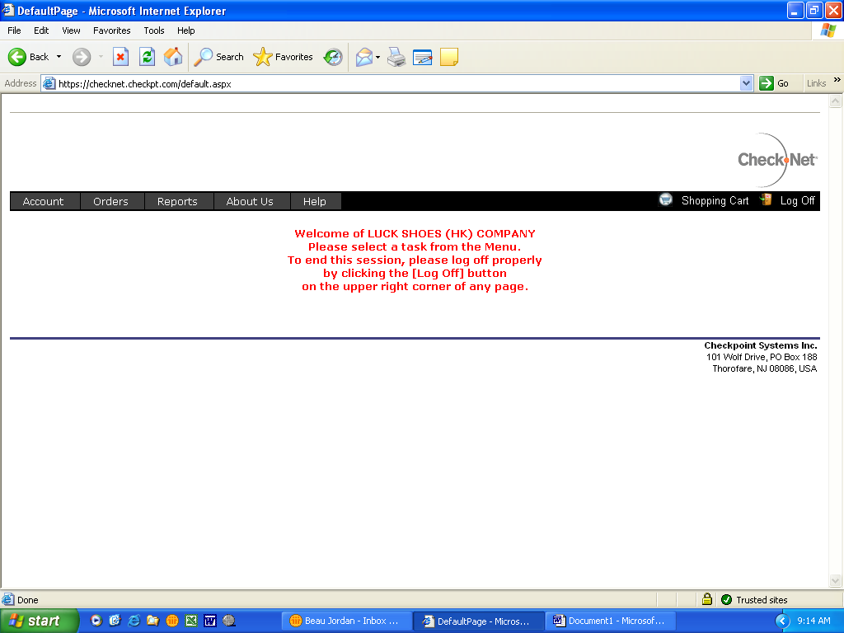

From here you need to go to the tab marked “Orders” and select “order from catalog”
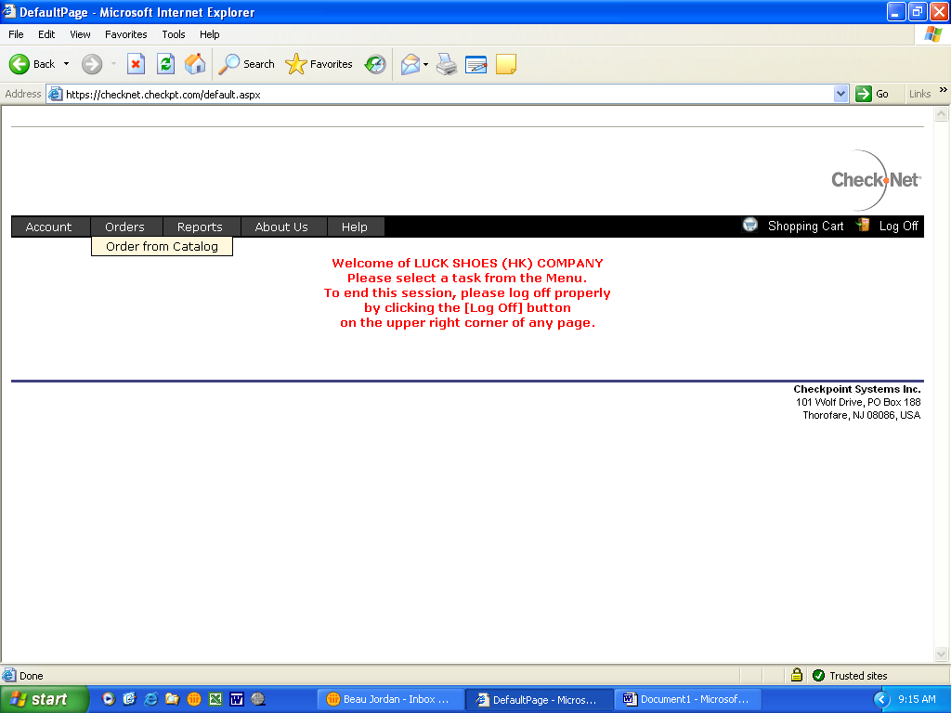
Once you select the catalog you will be taken to this screen.
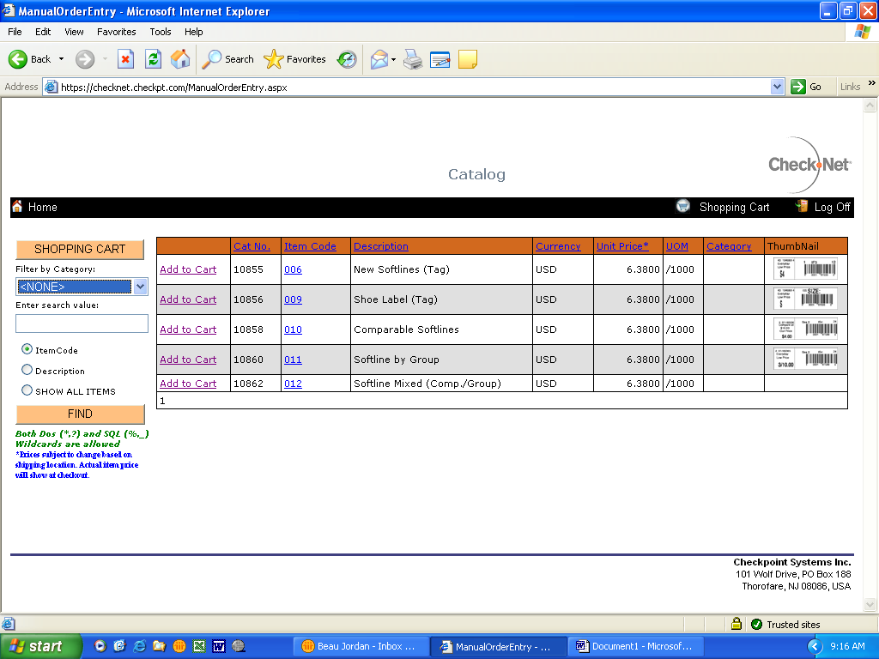
This screen gives you a list of the items you may order. To begin you must choose your item and click “Add to Cart”….for this demo I will use item 009. Once you select “Add to Cart” you will be taken to the manual entry screen…looks like this. Note this requires two screen shots as some of the fields are located to the far right of the page
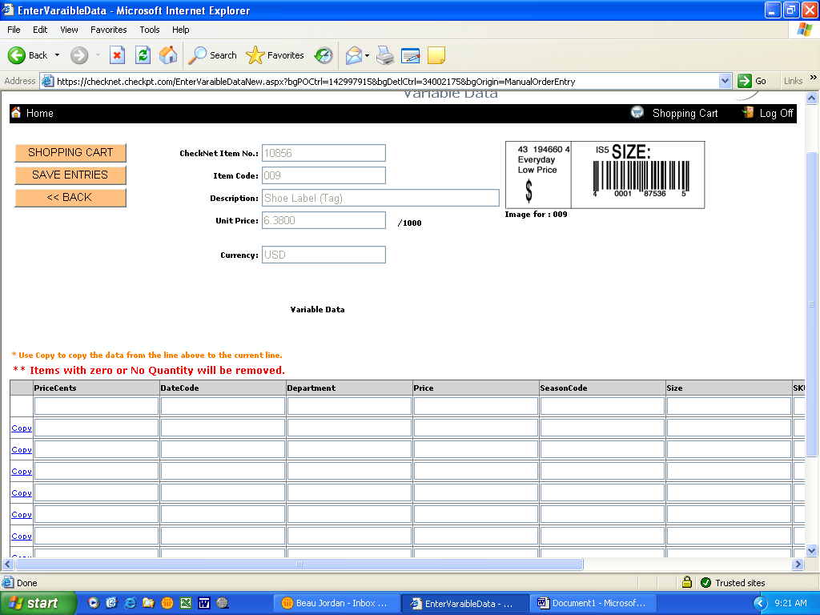
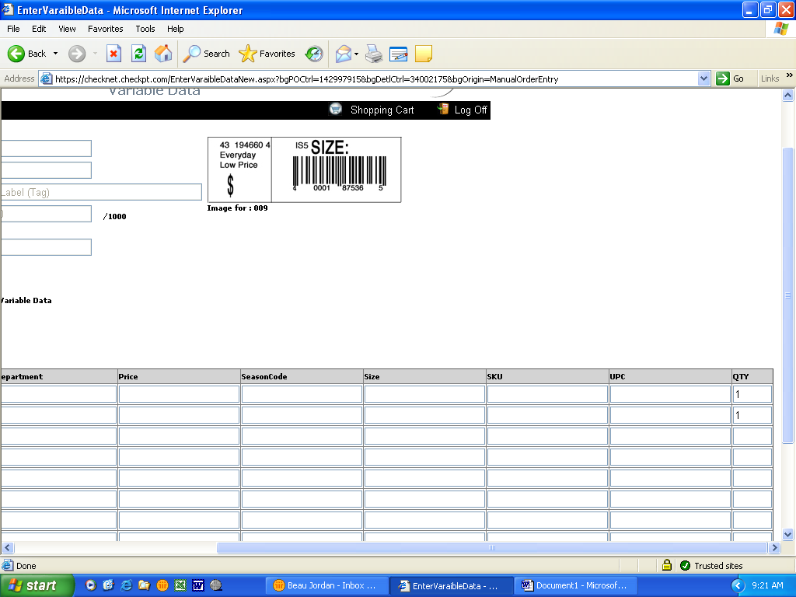
These are all the fields that you will have available to utilize. Please understand that anything that you put in these fields will print on the tickets, and if that information is wrong, you will be liable to place a new order for the correct data or quantities. Here is a samples shot of what the data will look like once entered. Again two screen shots since the screen is so wide.
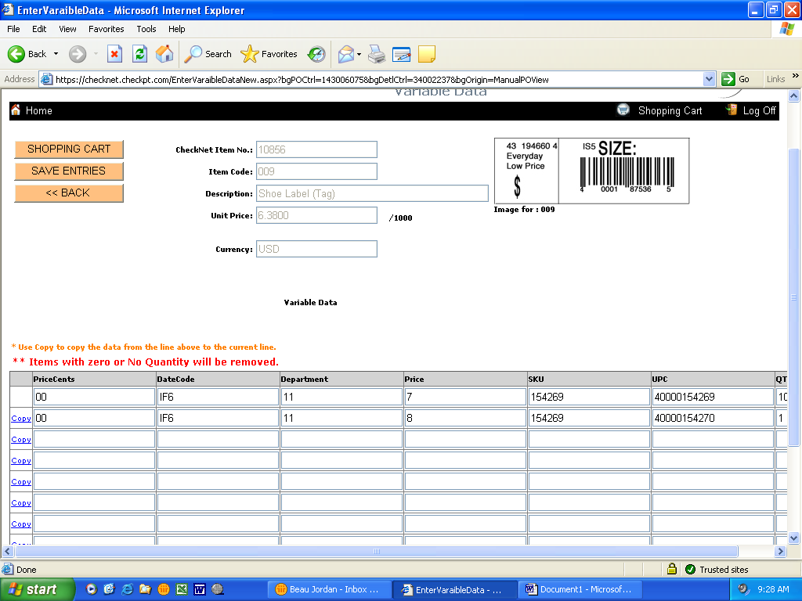
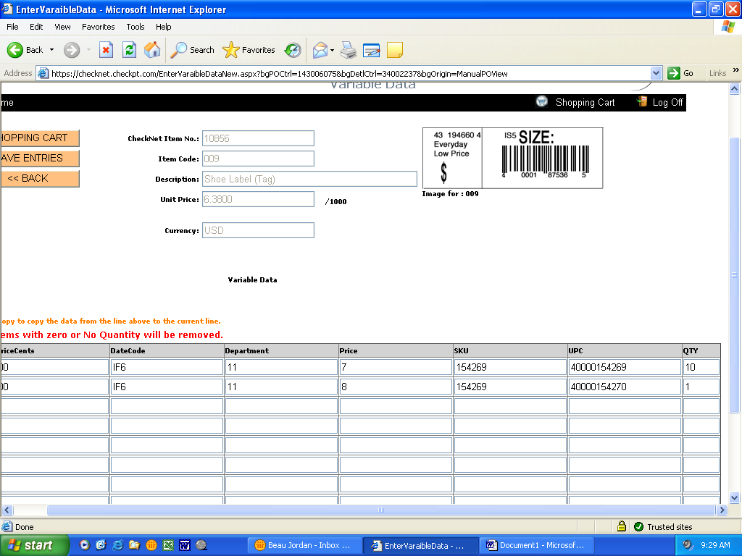
Please notice the two separate fields regarding the price of your tickets. You need to input the cents, separately from the dollar amount. You do not need to use (.) or the dollar sign ($) when entering this data. Just as simple as listed above. Cents (00), dollar amount (7). Once you have completed you order you must select “Save Entries”
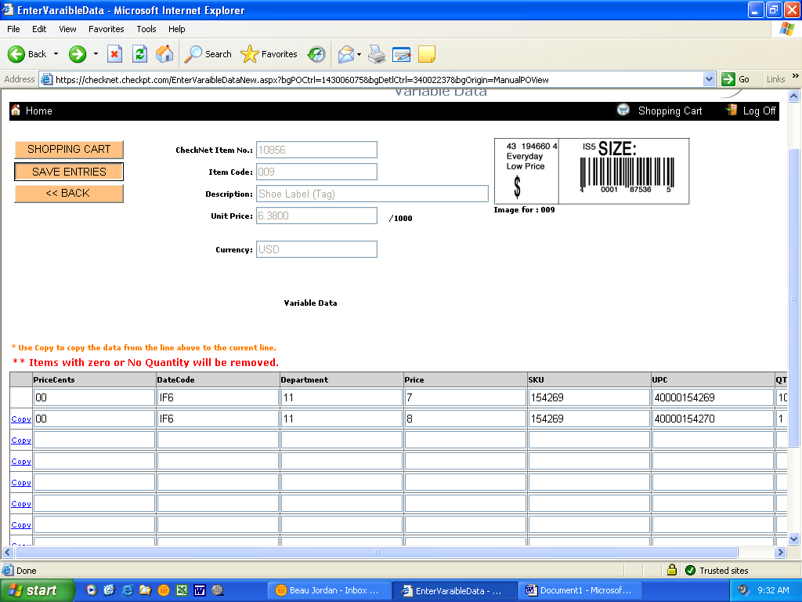
Then you will see that your data has been saved in red. This will look like this.
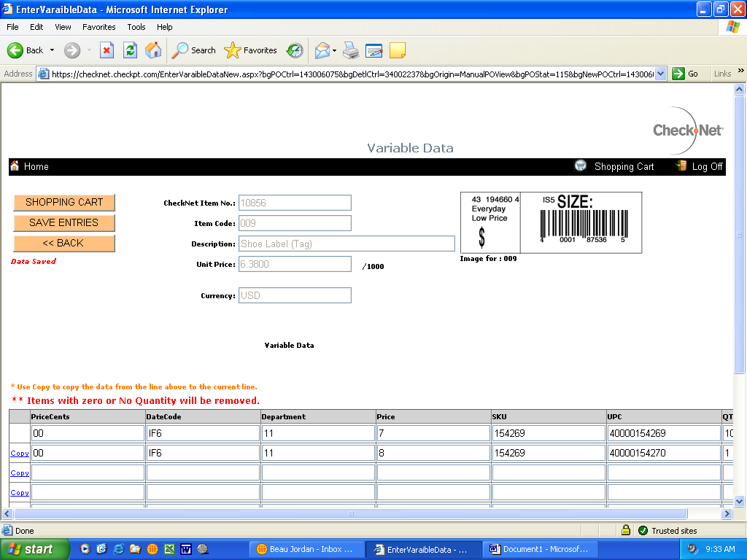
Next you will select the tab “SHOPPING CART”…….here is this view
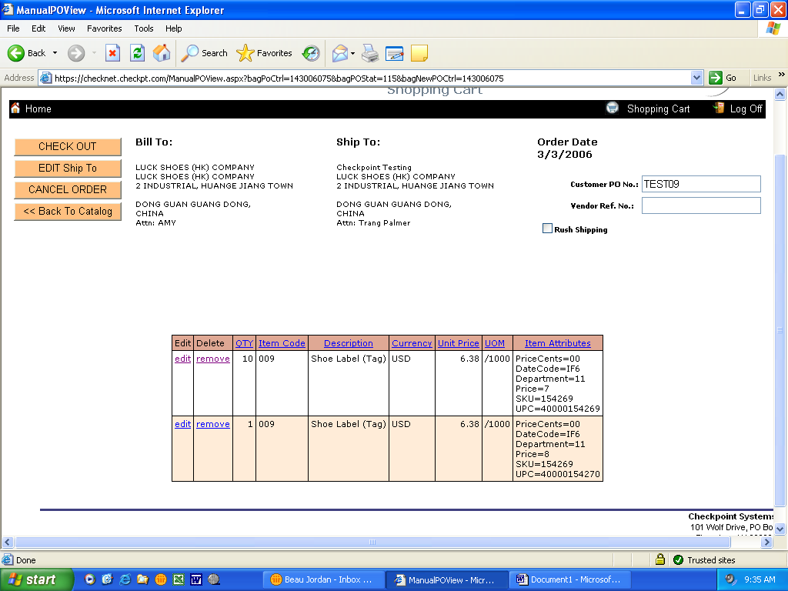
In this area you have the chance to review your order, change the ship to location, cancel the order, select the option for rush shipping (note a “rush” is only for the shipment method, not production) and enter a vendor reference number which can be something that you may utilize internally, but it is not a required field. Once you feel comfortable with your order you select the tab “CHECK OUT”. This will take you here:
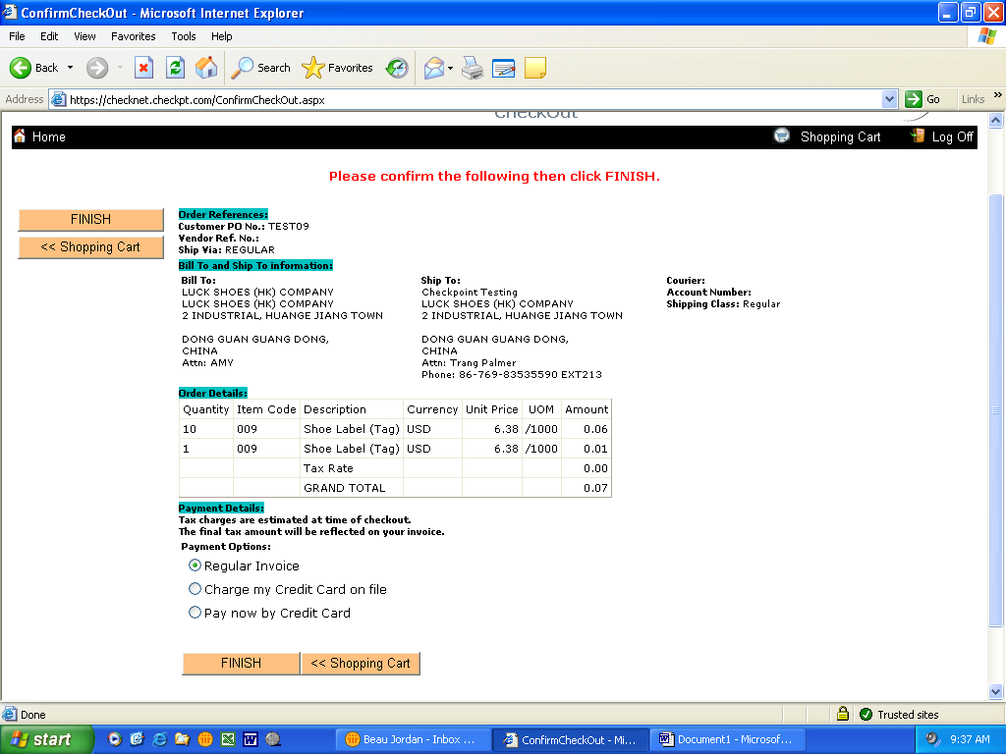
CheckNet will ask you again to make sure that everything looks correct because we know that you have a new responsibility of making sure your orders are correct and this provides those extra opportunities to catch mistakes. If you need to edit, just select “shopping cart” and follow the previous steps. Once you have confirmed the accuracy of the order select “FINISH”. This will bring you to the Order Confirmation page.
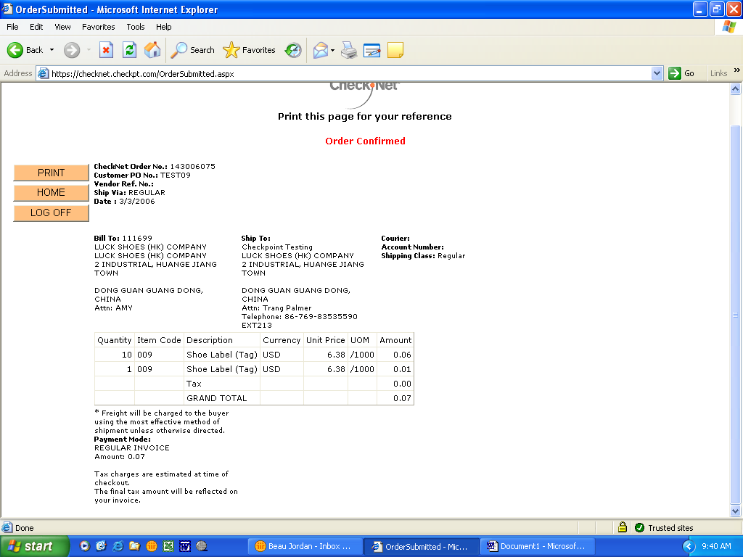
I strongly recommend printing this page out for your personal record so if you ever need to call me to discuss a P.O., you will have all of the pertinent information to help me research any issues.

You have know successfully completed a CheckNet manual catalog entry. Please review this document closely and again, I can be reached at 800-233-6215 x 249 and Email Yolanda.House@checkpt.com for any order questions, comments or concerns. We thank you for your business and I look forward to providing the best service available for you and your partners.

Yolanda House
Inside Account Manager
Checkpoint Systems Inc, Houston
5800 Corporate Drive
BLDG D
Houston, TX 77036

VARIETY WHOLESALER’S SOFTLINES IMPORT MANUAL

PRICE TICKET APPROVAL PROCEDURE

VARIETY WHOLESALER’S IMPORT MANUAL

PRICE TICKET APPROVAL PROCEDURE
Variety Wholesaler’s, Inc. requires each vendor to order their own price tickets. Price tickets are to be ordered from Checkpoint, International.

REVISED 3/12/06: Here are the steps to sending an email for approval of the data that you enter in for your Variety Wholesaler’s, Inc. tickets:
- Once you have entered in all of the data for a PO/PO’s you always move them to your shopping cart.
- Go to the shopping cart to actually finish your orders.
- You must make a copy of this screen (landscape print preview) that shows the ticket with all of the data you entered in for production. See the example of a screen printed and ready to email. Should you have any questions regarding order placement please notify Yolanda House at yolanda.house@checkpt.com or by phone at 800-233-6215 extension 249.
The buyer will approve the ticket by return email or will inform you of the necessary corrections to be made.

NOTE: The production sample should be sent to the buyer with the price ticket attached. Final approval of the price ticket will be completed on the sample approval form. (See “sample approval and lab testing” section).
VARIETY WHOLESALER’S SOFTLINES IMPORT MANUAL

PRICE TICKET PLACEMENT

VARIETY WHOLESALER’S IMPORT MANUAL

PRICE TICKET PLACEMENT GUIDELINES

WOMEN’S/GIRLS APPAREL

CATEGORY | TICKET LOCATION
Coats/Outerwear/Long Sleeve Dresses | Bottom of left sleeve at cuff seam
Long sleeve hanging tops/shirts | Bottom of left sleeve at the cuff seam
Short sleeve hanging tops/shirts | Under left arm – on the seam
Short sleeve dresses | Under left arm – on the seam
Sleeveless Tops/Tank Tops | Through manufacturers label at neck
Tops – Packaged – Folded | Through manufacturers label at neck
Loungewear/Sleep Wear | Through manufacturers label at neck
Sweaters – Hanging and Folded | Through manufacturers label at neck
Bottoms (Slacks, Jeans, Shorts, etc.) | On waistband seam – left side

VARIETY WHOLESALER’S IMPORT MANUAL

INFANTS/TODDLERS

CATEGORY | TICKET LOCATION
Diaper Sets/Creeper Sets | Through manufacturers label at neck
Tops | Through manufacturers label at neck
Dresses | Through manufacturers label at neck
Bottoms | On waistband seam – left side

MEN’S/BOY’S APPAREL

CATEGORY | TICKET LOCATION
Coats/Outerwear/Jackets | Bottom of left sleeve at the cuff seam
Long sleeve hanging tops/shirts | Bottom of left sleeve at the cuff seam
Short sleeve hanging tops/shirts | Under left arm – on the seam
Tops/shirts – folded | Through manufacturers label at neck
Sweaters – hanging | Through manufacturers label at neck
Sweaters – folded | Through manufacturers label at neck
Bottoms (slacks, jeans, shorts) | On waistband seam – left side

NOTE: For all garments with rubberized stamped label, place the price ticket under the left arm – on the side seam.

VARIETY WHOLESALER’S SOFTLINES IMPORT MANUAL

MAIN LABELS,
HANG TAGS, ETC.

VARIETY WHOLESALER’S IMPORT MANUAL

MAIN LABELS
Imported apparel must have the appropriate woven main labels.

NOTE: Rubberized stamped labels must be approved by the buyer.

HANG TAGS, JOKER TAGS, POCKET FLASHERS
Certain apparel will require some of the above listed tags. The buyer will advise as to which tags are required and the placement of the tags.

WOVEN CARE LABELS
All imported apparel must have a woven care label with the appropriate care instructions.

NOTE: If samples of labels/hang tags, etc. are required, contact the buyer.
VARIETY WHOLESALER’S SOFTLINES IMPORT MANUAL

GARMENT HANGER PROGRAM

VARIETY WHOLESALER’S IMPORT MANUAL

Variety Wholesaler’s, Inc. in an effort to achieve a consistent, quality look on our sales floor, has a preferred hanger source,
A & E products.

Enclosed you will find details concerning the A & E hanger styles, their global locations and an order form.

NOTE: Please use this order form when placing orders for hangers for Variety Wholesaler’s, Inc.

Customer Service Locations

A & E Products Group LP A & E Products Group LP
13335 Orden Drive 602 West Main Street
Santa Fe Springs, CA 90670 Ringtown, PA 17967
Toll Free Tel: 800-462-3843 Toll Free Tel: 800-655-0214
Toll Free Fax: 888-997-7575 Toll Free Fax: 800-655-0213

VARIETY WHOLESALER’S SOFTLINES IMPORT MANUAL

CARTON GUIDELINES

VARIETY WHOLESALER’S IMPORT MANUAL

CARTON GUIDELINES

Imported Merchandise Standards
Failure to follow these guidelines for cartons could result in a charge back or cancellation order.

CONSTRUCTING
CARTONS
- Material Requirements
- Individual Carton Size Requirements

MARKING
CARTONS
- Mandatory Markings
(As per VW Shipping Marks)
- Fragile Markings

Cartons produced for Variety Wholesaler’s, Inc. must meet the following requirements for materials and size requirements:

Material Requirements:
All cartons produced for Variety Wholesaler’s, Inc. must be manufactured using:
- Virgin fiber
- Water soluble glue
- Double corrugated (C fluting)
- On all consumers toy packaging, rivets must be used.
VARIETY WHOLESALER’S SOFTLINES IMPORT MANUAL

SHIPPING INSTRUCTIONS

VARIETY WHOLESALER’S IMPORT MANUAL

Requests for Cargo Booking
Cargo booking should be made seven to ten (7 to 10) days before the last ship date (EXO) of the purchase order. During peak shipping season, bookings should be made at least fourteen (14) days before the last ship date (EXO) on the purchase order.

- The following information must be provided to Expeditors at the time of booking:
  - Variety Wholesaler’s, Inc. PO number
  - Variety Wholesaler’s, Inc. style (SKU) number
  - Contact person, telephone, fax number and email
  - Consignee (Variety Wholesaler’s, Inc.)
  - Place of delivery – distribution center
  - Number of packages
  - Number of pieces
  - Case pack
  - Cube per case
  - Description of merchandise
  - Weight (in KG) and measurement (in CBM)
  - Cargo ready date
  - Statement certifying whether the shipment contains SOLID WOOD PACKING MATERIAL
  - FOB point

- All commercial documents from the vendor must be submitted to Expeditors origin 96 hours (4 days) prior to
CY Closing (Expeditors personnel will provide CY Closing date to the vendor).
- For CFS shipments, vendor must have the shipping approval when delivering cargo to the consolidator’s warehouse.
- CFS booking must prepare shipper order per PO/SKU.
- Booking multiple purchase orders is acceptable as long as they have the same ship date (EXO) for CY Shipment.

VARIETY WHOLESALER’S IMPORT MANUAL

VENDOR/C0NSOLIDATOR LOADING INSTRUCTIONS

Container Loading Instructions:
A. Loading of containers will be by purchase order and SKU numbers.
B. One carton from each purchase order should be placed at the tail of each container for customs inspection. This must be done on multiple origin port consolidation, as well as single origin consolidations.
C. A container manifest must be placed on a tail-loaded carton in each container.
D. If fumigation is necessary, the process can be done prior to delivery as long as the proper documentation is provided. If assistance is needed in locating a fumigation facility, please contact the local Expeditor’s office.

Use of Equipment: 20’, 40’, 40’ high cube and 45’ containers to be used as required to obtain maximum trailer utilization.

The guidelines are:

LOAD ABILITY | MAXIMUM WEIGHT
27 CBM | 36,000 LBS – 20’ (8’6”)
57 CBM | 40,000 LBS – 40’ (8’6”)
65 CBM | 40,000 LBS – 40 HQ (9’6”)
75 CBM | 40,000 LBS – 45’
Equal Distribution For Container Loading: When loading a container, the cargo should be under the specified weight restriction and evenly dispersed throughout the container.

VARIETY WHOLESALER’S IMPORT MANUAL

VENDOR DOCUMENT SUBMISSION

- All commercial documents (i.e. commercial invoice, packing list, etc.) must be submitted to Expeditors International 96 hours (4 days) prior to CY Closing (Expeditors will provide at time of booking). Transmission of commercial documents is acceptable via fax or email.
- If the documentation is not provided to Expeditors at least 96 hours (4 days) prior to CY Closing, the cargo will not be permitted to load the vessel and depart origin.
- If the commercial invoice quantity does not match the booked quantity, Expeditors International has the authority to stop the shipment and request instructions from Variety Wholesaler’s, Inc.
- The vendor is fully responsible for any charges that are incurred because of non-compliance to these requirements (i.e. storage, penalties, additional drays, etc.).
- Also, present Federal Communications commission (FCC) Form 740, Food and Drug Administration Form 2877 and License Agreement if applicable.

VARIETY WHOLESALER’S IMPORT MANUAL

VENDOR DOCUMENT CHECKLIST PROCEDURE

- It is the vendor and/or agent’s responsibility to ensure that all parties that will present documents to Expeditors have copies of the Vendor Document Checklist.
- The Vendor Document Checklist must be completed for each set of commercial documents. If three (3) sets of documents are prepared for one shipment, three (3) Vendor Document Checklists must be completed.
- Each set of commercial documents presented to Expeditors (which are used for customs clearance) must be accompanied by the Vendor Document Checklist. Expeditors will not accept any documents that are not accompanied by the Vendor Document Checklist.
- The Vendor Document Checklist must be signed and dated by a factory or vendor representative, which indicates that the documents have been reviewed against the checklist.
- As required by Variety Wholesaler’s, Inc., Expeditors will verify the information provided on the Vendor Document Checklist. If a requirement is applicable, “yes” or “no” must be checked. If a requirement is not applicable (n/a), “n/a” must be checked.
- Any item marked “no”, or not marked at all, will automatically result in denial of FCR release by Expeditors. Expeditors will request revised documents or any missing documents before the FCR is released.
- Revised or missing documents must be submitted to Expeditors within 24 hours of request.
- Upon receipt of revised or missing documents, the Vendor Document Checklist will be re-verified by Expeditors.
- When applicable document requirements have been satisfied, Expeditors will release the FCR.

PLEASE NOTE THE FOLLOWING:

- This checklist will not affect the letter of credit payment, but it will affect the release of the FCR. Expeditors has been instructed by Variety Wholesaler’s, Inc. to hold the FCR until all requirements on the checklist are satisfied. Also, the checklist does not insure that the letter of credit will be without discrepancies.
- Only Variety Wholesaler’s, Inc. can waive a requirement on the checklist. Requirements will only be waived by Variety Wholesaler’s, Inc. if the vendor can provide documentation that the requirement is not needed. The FCR will not be released until Variety Wholesaler’s, Inc. has made the final determination on the requirement.
- Any problems with the checklist or procedures should be communicated to the import department.
VARIETY WHOLESALER’S SOFTLINES IMPORT MANUAL

VENDOR CHARGEBACKS

VARIETY WHOLESALER’S IMPORT MANUAL

VENDOR CHARGE BACKS
Each vendor must be aware that there are certain discrepancies
which will result in an automatic charge back to the vendor/supplier/factory. The standard charge back is 5% of the FOB value of the purchase order affected.

The vendor or factory will receive notification of the charge back with specific details justifying the action.

COMMON CAUSES FOR CHARGE BACKS:

INCORRECT FREIGHT CALCULATION

- Vendor/Agent uses incorrect freight on quote sheet.
- Vendor/Agent calculates freight X carton cube incorrectly.

INCORRECT QUANTITIES RECEIVED

- Shortage: Based on entry documentation to US Customs vs. Variety Wholesaler’s DC Receipt
- Overage: Based on entry documentation to US Customs vs. Variety Wholesaler’s DC Receipt

INCORRECT CARTON MARKINGS

- Carton markings must be pre-printed; do not use labels, tape, etc.
- Correction on markings are acceptable if legible and done with waterproof pen.
- Consolidator will not accept CFS cartons if marked with labels, tape,etc.

INCORRECT CASE PACK OR CUBE

- Consolidator will verify case pack and will not accept different case pack for CFS or CY bookings.
- Consolidator will verify carton cube of the case to the carton cube stated on the purchase order.
- Charge back will be calculated by the carton cube discrepancy by the number of cartons in the shipment.

LATE SHIPMENTS

- Shipments which are later than the latest ship date stated on the purchase order.

DOCUMENTATION PROBLEMS

- Incorrect documents – incorrect FOB, incorrect Visa, late documents, etc.

NOTE: Variety Wholesaler’s, Inc. reserves the right to delay any shipment until documentation problems are resolved. Any demurrage charges, etc. will be for vendor’s account.
RECEIVING REQUIREMENTS
To expedite the unloading time at Variety Wholesaler’s, Inc., the following guidelines shall be followed. Failure to follow these guidelines will cause longer unloading time and shall result in Variety Wholesaler’s, Inc. assessing a charge back to the vendor as specified.

- It is the vendor’s responsibility to review the purchase orders prior to shipping, for any changes that are necessary. This would include, but not limited to, changes in units ordered, costs, freight terms, payment terms, items ordered. Any changes or corrections that need to be made to any purchase order, it is the vendor’s responsibility to contact the buyer prior to shipping for the buyer’s approval of the change.

- All merchandise shall be shipped in the packs and assortments (size and color) of the style number specified on the Variety Wholesaler’s, Inc.’s purchase order. Only one style number shall be shipped per box, case, or carton. If not returned, the vendor/shipper shall be assessed handling and storage charges for the repacking of the goods by Variety Wholesaler’s, Inc.

- Merchandise shipped shall be the same as the approved samples. Failure of the vendor/shipper to comply shall result in the merchandise being returned at the vendor’s expense. The vendor/shipper shall be assessed handling charges.

- The style number stamped or printed (1/2 inch minimum height) on the outside of the box, case, or carton shall match the contents of the box, case, or carton. All merchandise shipped with incorrect identification shall be processed at the discretion of Variety Wholesaler’s, Inc.

- When a trailer is floor stacked by a vendor/shipper, the boxes, cases, or cartons shall be presorted by Variety Wholesaler’s, Inc.’s purchase order number and Variety Wholesaler’s, Inc.’s SKU number found on the purchase order. The side of the box, case, or carton with the style number on it must face the rear of the trailer (door). Attached to the last case loaded and facing the trailer door must be a packing list containing the number of cases of each different items shipped. Failure to comply will result in handling charges being assessed against the vendor/shipper.

