Required Instructions:
Appendixes 1 to 6 are template forms as examples. Each of these forms should be downloaded, completed with accurate information on company letterhead inserting mandatory verbiage from example forms, and then submitted to VWI prior to purchase/shipment.

Direct Import IPR Template Forms
Appendix 1 to 6
Intellectual Property Rights (IPR) Compliance Guide
Appendix 1.
Trademark/ Trade Name Release Letter (example only)

Edit and complete as needed for all intellectual property rights (use company letterhead)
XYZ Global Products, Ltd.
10th Floor, Occidental Plaza,
No 84 Mody Road, Kowloon
Hong Kong
To: __________________________________
With this letter, XYZ Global Products Ltd. certifies that _____________ the trademark owner has granted our company authorization / permission to sell the trademark / trade name merchandise as registered: _____________ to Variety Wholesalers Inc. (“Variety”) for import, distribution and sales in Variety U.S. stores. A copy of the USPTO registration (Trademark registrations), Customs Recordations (CBP – IPRS database) and Copyright registration are attached. We understand that the provisions in the Variety Wholesalers, Inc. Supplier Indemnification Agreement include without limitation, suppliers obligation to defend and indemnify Variety if a claim is brought against Variety Wholesalers, Inc. regarding a product we sell to Variety Wholesalers, Inc. This includes any claim a product, including the product labeling or packaging, violates the intellectual property rights (trademark, service mark or copyright) of another person, company or entity.
______________understands that this letter is binding and relies on trademark owner authorization. ______________ will advise the Variety Wholesalers Inc. buyer and import department immediately if the trademark owner changes, withdraws, cancels any authorization or permission to sell the trademarked goods. Variety has full rights to cancel, refuse, recall or return for refund any trademarked merchandise not authorized for sale or with counterfeit/ infringing marks.

__________________________________ (Signature)

__________________________________ (Printed Name)

__________________________________ (Title)
__________________________________ (Date)

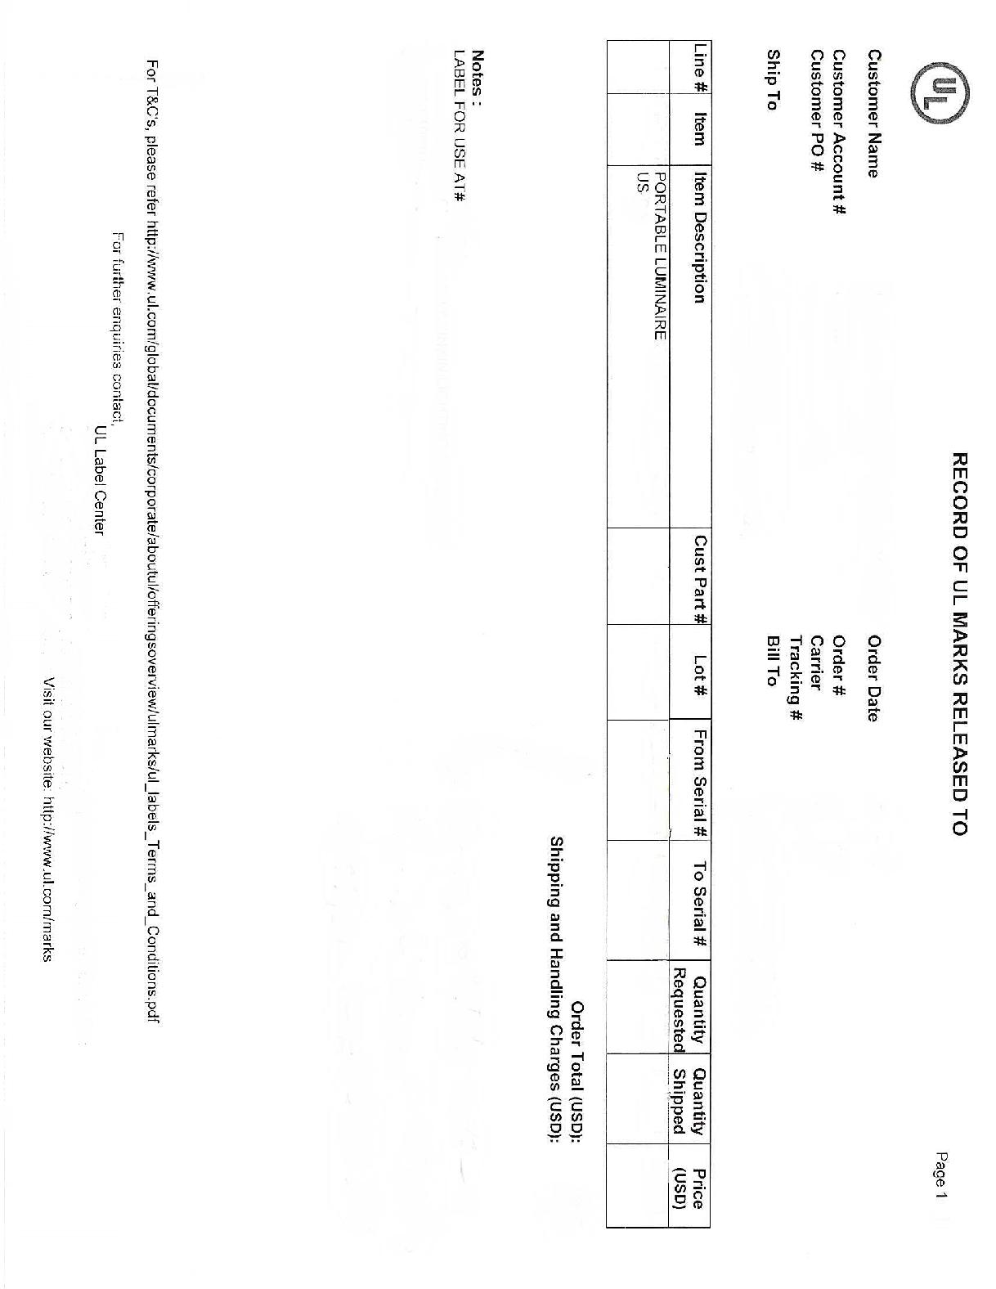
Appendix 2.

LICENSE AGREEMENTS – Letter of Authorization (example only)

(COMPANY LETTERHEAD)
TOYS FOR KIDS INC
2114 West 44th Street
New York, NY 10118
(DATE)
January 1, 2018

United States Customs Service
Entry, Licensing & Restricted Merchandise Branch
1301 Constitution Avenue N.W. Washington, D.C. 20229

ATTN: National Director of Customs

To Whom It May Concern:
(LICENSEE) (OVERSEAS OFFICE)
This letter is to confirm that TOYS FOR KIDS INC. and TOYS FOR KIDS HONG KONG LTD. is an authorized licensee of _______________ for the following Properties in the United States of America and other countries as listed below and in the enclosed letter / contract from the Licensor.
Batman
Superman
Wonder Woman
(LICENSEE) (OVERSEAS OFFICE)
Variety Wholesalers Inc. is a Retail & Distribution customer of TOYS FOR KIDS INC and TOYS FOR KIDS HONG KONG LTD and is authorized to purchase, import, distribute and sell the licensed products listed in the enclosed contract and attached product list in Variety stores.
.
(SIGNED BY AUTHORIZED LICENSEE OFFICER/ REP)
Best Regards,

Vice-President & General Manager
TOYS FOR KIDS, INC
2114 West 44th Street
New York, NY 10118

Appendix 3.
RECORD OF UL MARKS RELEASED (example only)

Appendix 4.
GENUINE UL LISTING MARKS (example only)
Genuine UL Listing Marks consist of four elements that can be found on the product in the form of a label, die-stamping, molding, or silk-screening (in certain circumstances this information may appear only on the packaging). Knowing this information may help to verify legitimate UL Marks.
The four elements of a genuine UL Mark are:
- The name and/or certification mark of Underwriters Laboratories (UL in a circle).
- The word “LISTED” in capital letters.
- A control number (four alpha-numeric characters) or issue number (sequence of typically 4 to 6 numbers). The issue number may or may not be preceded by one or two letters and may or may not be preceded by the phrase “Issue No.”
- A product identity (what the product is).
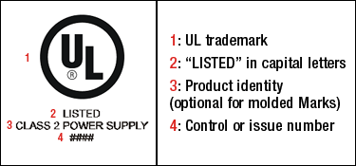
Other markings that may appear next to or in the vicinity of the Listing Mark are:
- UL file number (for most products this number is prefixed with an “E”).
- Company name or logo.
- Model, catalog or type designation.
- Electrical ratings.
MARKS FOR UL’S LISTING SERVICE
If a product carries one of these marks, it means UL found that representative product samples met UL’s requirements. These marks appear on end products and complete components suitable for factory and field installation. All of the products carrying these marks are covered by our Follow-Up Services Program to determine that products continue to be manufactured in compliance with UL’s safety requirements. Source: http://www.ul.com
Appendix 5.

UL MARKS - PHOTO SPREADSHEET (example only)
PO#123456
ITEM# | SKU# | PICTURE | QTY | UL Serial#
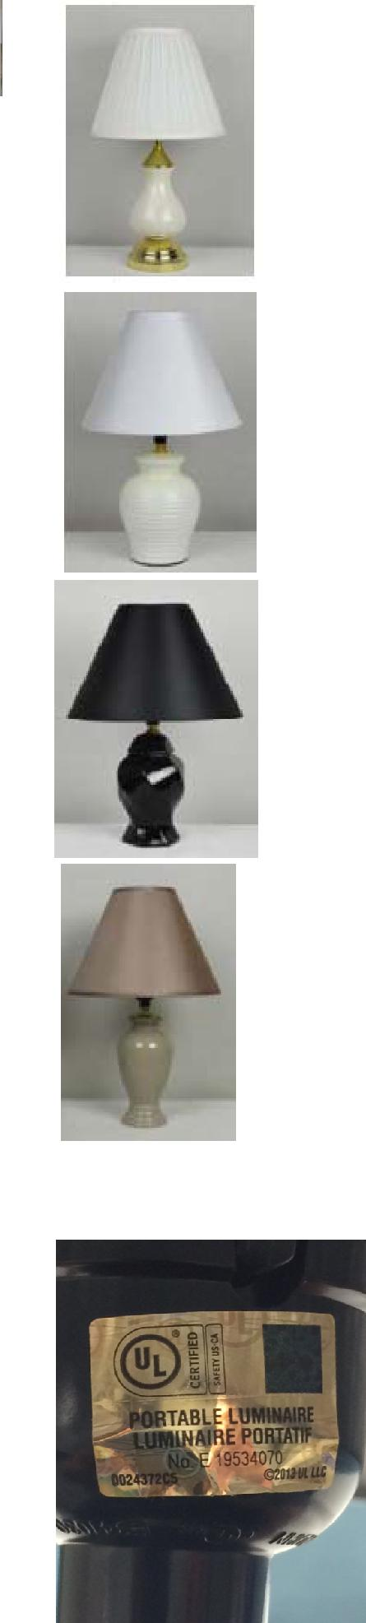  LS150701 | 507795 |  | 540 | I89731415-I897314954
LS150702 | 507796 |  | 1218 | I897314955-I89733172
 |  |  |  | I89733173-I89734242
LS150703 | 507797 |  | 1380 | (1070)
 |  |  |  | K68510887-K68511196
 |  |  |  | (310)
LS150704 | 507798 |  | 594 | K68511197-K68511790

Appendix 6.
IPR (INTELLECTUAL PROPERTY RIGHTS) RESOURCES:

1) United States Patent and Trademark Office (USPTO)
https://www.uspto.gov/trademark
2) CBP – INTELLECTUAL PROPERTY RIGHTS (RECORDATION) - IPRS
https://iprs.cbp.gov/#/
3) United States Copyright Office (Search)
http://cocatalog.loc.gov/cgi-bin/Pwebrecon.cgi?DB=local&PAGE=First
4) United States International Trade Commission (ITC) Exclusion Orders
https://www.usitc.gov/intellectual_property/exclusion_orders.htm
5) Informed Compliance Publications
https://www.cbp.gov/
6) Customs Rulings Online Search System (CROSS)
https://www.cbp.gov/trade/rulings

