Direct Import Compliance Guide
Please download for reference

Variety Wholesalers, Inc.
218. South Garnett Street
P.O. Box 947 Henderson, NC 27536
Phone: (252) 430-2600

Intellectual Property Rights (IPR) Compliance Guide

Variety Wholesalers, Inc.
Intellectual Property Rights (IPR) Compliance Guide
1/2/2018
This guide on IPR (Intellectual Property Rights) compliance is in addition to our import manual, and every Variety Wholesalers Inc. (“Variety”) vendor, supplier and manufacturer is required to comply with all guidelines, policies and procedures contained in this guide, the Import Manual(s) and all other compliance instructions issued by Variety Wholesalers Inc. This guide will be uploaded, with critical documents and examples, to the Variety website and available on www.vwstores.com under Imports. The guide will be updated and revised as needed and the revision date will be shown on the first page or on any separate IPR related online document. Variety Wholesalers Inc. is committed to ensuring that all products purchased, imported, distributed and sold at our stores comply with all federal, state and local laws including U.S. intellectual property rights laws and regulations.
Compliance with all U.S. IPR laws and Variety policies and procedures is mandatory. Please send copies of this guide to all of your U.S. and overseas facilities and key personnel to be sure this guide is understood and all best practices and IPR compliance processes are followed. Vendors must review and understand the information in this guide to become familiar with the intellectual property laws and compliance policies. Intellectual property (IP) is a set of laws that protect creative and innovative products through legal rights including trademarks, copyrights, and patents. Variety Wholesalers Inc. (“Variety”) supports IP protection and requires all our vendors to do everything necessary to ensure compliance.

- Variety requires all direct import vendor /suppliers to read, understand, and comply with all policies, procedures and instructions in the Intellectual Property Rights (IPR) Compliance Guide. Intellectual Property Rights (IPR) including trademarks, copyrights, and patents are protected in the U.S. by a series of laws that protect creative and innovative products from counterfeiting or infringement.
- The legal rights of the owner of a trademark, copyright, patent and other registered or copyrighted certification marks, logos and design marks are entitled to protection under U.S. IPR laws.
- Variety requires that every mark incorporated into merchandise, including product packaging and instructions inside the package, be checked and verified to ensure that all trademarks and copyrights are genuine, properly authorized, and the vendor / seller is 1) the owner of the mark(s) or 2) an authorized licensee or 3) has written permission / authorization from the trademark owner to sell the product to Variety for import, distribution and sale in our stores.

Customs and Border Protection (CBP) enforces trademark laws and Intellectual Property Rights regulations at U.S. ports of entry. IPR infringement and counterfeiting involves the use of a protected intellectual property right without the authorization of the owner of the right. Customs authority to enforce patent rights is limited to providing patent protection pursuant to exclusion orders issued by the U.S. International Trade Commission (ITC).
Owners of federally registered trademarks and copyrights may also record their rights with Customs. The Customs IPR website contains information on recorded rights. Agency policy is to focus IPR enforcement efforts on recorded trademarks, trade names and copyrights. As such, recorded trademarks and copyrights receive a higher level of protection than unrecorded rights. However, Customs may take action to protect registered but unrecorded trademarks and copyrights against counterfeit trademarks and clearly piratical copies.
Customs (CBP) will focus its enforcement on trademarks, trade names and copyrights that are registered in the U.S. Patent and Trademark Office (USPTO) database, the U.S. Copyright Office database and recorded in the CBP Intellectual Property Rights (IPRS) database. See Appendix 6: IPR (INTELLECTUAL PROPERTY RIGHTS) RESOURCES for website addresses. All 3 online databases are public and free to search. Vendors/ suppliers/ manufacturers are advised to search for trademarks, trade names, design marks, copyrights and CBP recordations before offering merchandise for sale to Variety.
U.S. Customs has the legal authority to inspect all shipments and make determinations whether a product or packaging has counterfeit or infringing trademarks, trade names or copyright materials. Customs has the authority to initiate enforcement actions including detention and seizure of merchandise that is considered counterfeit or infringes on a registered trademark or copyright.
Seizure for IPR violations is to be avoided at all times. If the goods are seized, CBP has interpreted the law to mean it has little or no flexibility. Unless the vendor or importer is able to quickly prove that the IPR owner has granted permission to use the intellectual property or proof the merchandise is from an authorized licensee, there is very little time to get the goods released and avoid seizure. Seized goods that Customs determines are in violation are often forfeited to the government and a civil penalty imposed upon the importer. This penalty is based upon the manufacturer’s suggested retail price as determined by Customs as if the goods were properly authorized.
Vendors, manufacturers, suppliers, and distributors must implement the following best practices and practical measures to ensure Intellectual Property Rights (IPR) compliance including the following before orders are issued or shipped on any IP regulated merchandise:
(1) Obtain and verify the owner’s permission to use all trademarks and copyrighted works during product design and development. See Appendix 1 for Trademark/ Trade Name Release Letter (example only)
(2) Evaluate the content of not only the goods, but also product packaging, owners’ manuals, and other product literature for trademark and copyright materials and markings.
(3) Provide complete, current and signed, English-language License Agreements from licensors authorizing the licensee to sell the branded/ licensed product(s) to Variety Wholesalers, Inc. (the customer) for import, distribution and sale in our stores. See Appendix 2 for LICENSE AGREEMENTS – Letter of Authorization (example only)
(4) Maintain detailed records regarding manufacturers, outside component sources and copies of all agreements between the vendor/supplier/ manufacturer and the owner of the trademark, trade name, copyright or patent. Verify that all agreements are still current and valid.
(5) Ensure all products comply with consumer product safety standards and requirements issued or administered by the Consumer Product Safety Commission (the “CPSC”) and other federal, state and local agencies. Many products, including children’s products, must be tested for conformity by a third party accredited lab.
6) Variety also requires UL testing, inspection and certification of manufacturers and specific products to the required standards. Genuine registered (trademark) UL marks/ labels are required on corded electrical product including lamps, seasonal (Christmas & temporary) electric light sets / strings / trees /wreaths/candles, extension cords and power adapters. Factory inspection / certification / testing by UL are required for these products and Variety will require ongoing verification of UL marks and labels.
A. All vendors using UL labels or marks must provide copies of the RECORD OF UL MARKS RELEASED TO the factory. See Appendix 3 for RECORD OF UL MARKS RELEASED (example only)
B. Photos or samples of UL labels with all codes & numbers for production goods must be sent to the Variety buyer for approval. See Appendix 4 for GENUINE UL LISTING MARKS (example only)
C. Each product must be pictured on a spreadsheet by Purchase Order number with the UL serial number or other unique code(s) on the UL Mark or label. UL has a strict “zero tolerance policy” on their registered labels and marks on products and packaging. All UL marks & designs are registered with both the U.S. Patent and Trademark Office (USPTO) and recorded in Customs IPR database for maximum enforcement power. Merchandise with “counterfeit” UL marks or labels on the product or packaging is subject to seizure by U.S. Customs. See Appendix 5 for UL MARKS - PHOTO SPREADSHEET (example only)

It is critical that the requirements within this guide are followed by all of our vendors so that Variety Wholesalers can continue to provide our customers with safe, compliant and affordable products. Our success in doing this is dependent on you and we recognize, appreciate, and greatly value your partnership.

Variety Wholesalers Inc. policy and goal is 100% compliance on IPR (Intellectual Property Rights) and preventing counterfeit or pirated product from entering our supply chain. Accordingly, we require current licenses and authorizations from the actual IP owner or licensor for any trademarks, trade names, copyrights or patents incorporated in the merchandise or its packaging we import. Any vendor selling Variety Wholesalers trademarked, copyrighted and/ or patented merchandise must provide the required documentation and proof it is authorized to sell such merchandise to Variety Wholesalers and that selling such merchandise to Variety Wholesalers will not interfere or infringe on the intellectual property or other rights of any third party, including the trademark owner or licensor in the case of licensed / branded product. We expect cooperation as our buyers (and Import department) need your help in checking and verifying to make sure the vendor’s trademark and copyright authorizations are valid, genuine and current in advance of shipment.
Please be aware that the provisions in the Variety Wholesalers, Inc. purchase order and the Supplier Indemnification Agreement includes without limitation, the obligation to defend and indemnify Variety if a claim is brought against Variety Wholesalers, Inc. regarding a product you sell to Variety Wholesalers, Inc. This includes any claim a product, including the product’s labeling or packaging, violates the intellectual property rights (patent, trademark, service mark or copyright) of another person, company or entity. Variety reserves the right to cancel all orders, refuse delivery of in transit goods and re-export / return any merchandise that is in violation of intellectual property rights and all related expenses are to the account of the vendor.
To assist you in creating compliant and safe product, Variety is establishing a Compliance & Product Safety Program which consists of this manual chapter, written policies and standards and verification programs to monitor compliance.
As you work through this manual, you will see links leading to additional documents which function as critical addendums. In an effort to make this manual a comprehensive resource, the documents attached and the links provided will be updated and expanded periodically. The manual also contains a list of links to external websites which serve as resources and provide access to information on registered trademarks (USPTO), copyrights, Customs database of recorded trademarks (IPRS), United States Copyright Office and more.

We require the following prior to allowing shipment of any product protected by IP rules, regulations, federal and state laws.
TRADEMARKS AND TRADE NAMES
A trademark is a word, name, mark, symbol, device, color or combination thereof used to identify and distinguish goods from those manufactured or sold by others and to indicate the source of the goods. Trademarks must be registered with the United States Patent and Trademark Office (PTO) to receive IPR protection from Customs. A trade name is the name under which a company does business.

Trademark Release Letter
Variety Wholesalers, Inc. requires vendors provide proof of their right to sell trademarked merchandise to Variety. Variety requires a Trademark Release Letter from the trademark owner. A copy of the USPTO registration and Customs recordation should also be provided. No shipment will be approved without a Trademark Release Letter sent to the buyer and copied to the Variety Import Department. See Appendix 1 for Trademark/ Trade Name Release Letter (example only)

LICENSE AGREEMENTS
If the trademark or brand is licensed, we require a Letter of Authorization on Licensee Letterhead, signed by an officer of the licensee company confirming that the licensee has the full authority to make, distribute and sell the products and that Variety Wholesalers Inc., the purchaser / customer, is fully authorized to purchase, import, distribute and sell all the licensed products offered and selected by Variety in our U.S. stores as per your license agreement. We require a complete, signed and current License Agreement for our records. Any changes or updates to the agreement should be sent to the buyer’s attention and copied to Variety Wholesalers Inc. Import Dept. See Appendix 2 for License Agreements – Letter of Authorization (example only)

Appendix 1.
Trademark/ Trade Name Release Letter (example only)

Edit and complete as need for all intellectual property rights (use company letterhead)
XYZ Global Products, Ltd.
10th Floor, Occidental Plaza,
No 84 Mody Road, Kowloon
Hong Kong
To: __________________________________
With this letter, XYZ Global Products Ltd. certifies that _____________ the trademark owner has granted our company authorization / permission to sell the trademark / trade name merchandise as registered: _____________ to Variety Wholesalers Inc. (“Variety”) for import, distribution and sales in Variety U.S. stores. A copy of the USPTO registration (Trademark registrations), Customs Recordations (CBP – IPRS database) and Copyright registration are attached. We understand that the provisions in the Variety Wholesalers, Inc. Supplier Indemnification Agreement include without limitation, suppliers obligation to defend and indemnify Variety if a claim is brought against Variety Wholesalers, Inc. regarding a product we sell to Variety Wholesalers, Inc. This includes any claim a product, including the product labeling or packaging, violates the intellectual property rights (trademark, service mark or copyright) of another person, company or entity.
______________understands that this letter is binding and relies on trademark owner authorization. ______________ will advise the Variety Wholesalers Inc. buyer and import department immediately if the trademark owner changes, withdraws, cancels any authorization or permission to sell the trademarked goods. Variety has full rights to cancel, refuse, recall or return for refund any trademarked merchandise not authorized for sale or with counterfeit/ infringing marks.

__________________________________ (Signature)

__________________________________ (Printed Name)

__________________________________ (Title)
__________________________________ (Date)

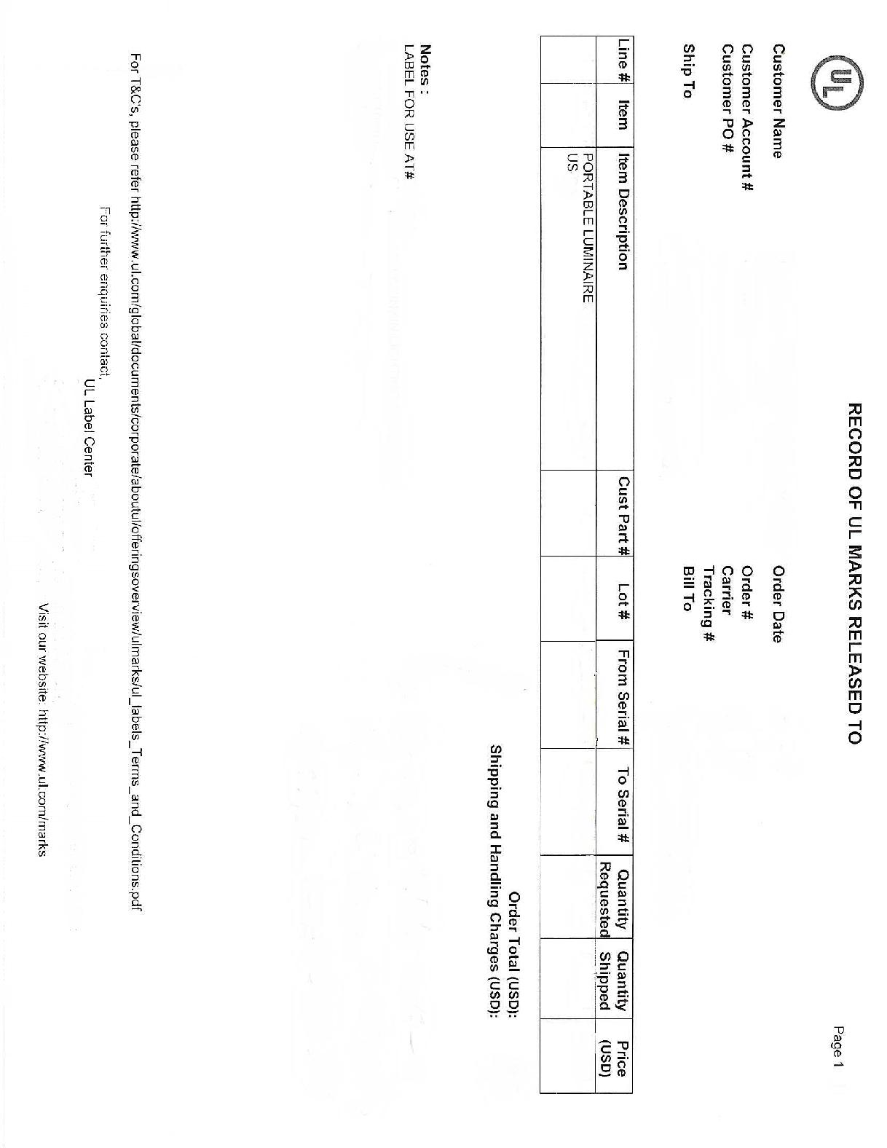
Appendix 2.

LICENSE AGREEMENTS – Letter of Authorization (example only)

(COMPANY LETTERHEAD)
TOYS FOR KIDS INC
2114 West 44th Street
New York, NY 10118
(DATE)
January 1, 2018

United States Customs Service
Entry, Licensing & Restricted Merchandise Branch
1301 Constitution Avenue N.W. Washington, D.C. 20229

ATTN: National Director of Customs

To Whom It May Concern:
(LICENSEE) (OVERSEAS OFFICE)
This letter is to confirm that TOYS FOR KIDS INC. and TOYS FOR KIDS HONG KONG LTD. is an authorized licensee of _______________ for the following Properties in the United States of America and other countries as listed below and in the enclosed letter / contract from the Licensor.
Batman
Superman
Wonder Woman
(LICENSEE) (OVERSEAS OFFICE)
Variety Wholesalers Inc. is a Retail & Distribution customer of TOYS FOR KIDS INC and TOYS FOR KIDS HONG KONG LTD and is authorized to purchase, import, distribute and sell the licensed products listed in the enclosed contract and attached product list in Variety stores.
.
(SIGNED BY AUTHORIZED LICENSEE OFFICER/ REP)
Best Regards,

Vice-President & General Manager
TOYS FOR KIDS, INC
2114 West 44th Street
New York, NY 10118

Appendix 3.
RECORD OF UL MARKS RELEASED (example only)

Appendix 4.
GENUINE UL LISTING MARKS (example only)
Genuine UL Listing Marks consist of four elements that can be found on the product in the form of a label, die-stamping, molding, or silk-screening (in certain circumstances this information may appear only on the packaging). Knowing this information may help to verify legitimate UL Marks.
The four elements of a genuine UL Mark are:
- The name and/or certification mark of Underwriters Laboratories (UL in a circle).
- The word “LISTED” in capital letters.
- A control number (four alpha-numeric characters) or issue number (sequence of typically 4 to 6 numbers). The issue number may or may not be preceded by one or two letters and may or may not be preceded by the phrase “Issue No.”
- A product identity (what the product is).
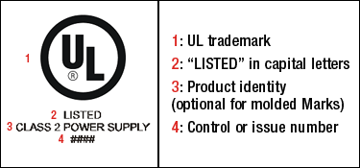
Other markings that may appear next to or in the vicinity of the Listing Mark are:
- UL file number (for most products this number is prefixed with an “E”).
- Company name or logo.
- Model, catalog or type designation.
- Electrical ratings.
MARKS FOR UL’S LISTING SERVICE
If a product carries one of these marks, it means UL found that representative product samples met UL’s requirements. These marks appear on end products and complete components suitable for factory and field installation. All of the products carrying these marks are covered by our Follow-Up Services Program to determine that products continue to be manufactured in compliance with UL’s safety requirements. Source: http://www.ul.com
Appendix 5.

UL MARKS - PHOTO SPREADSHEET (example only)
PO#123456
ITEM# | SKU# | PICTURE | QTY | UL Serial#
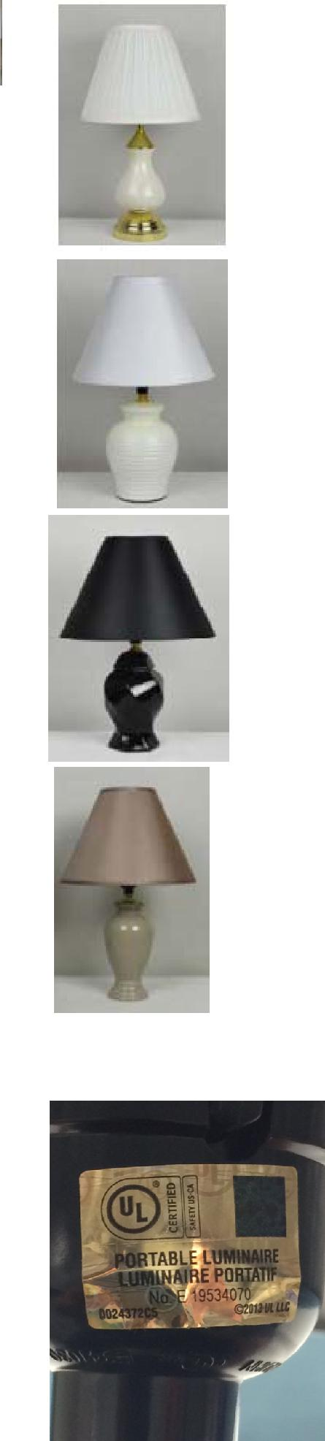
LS150701 | 507795 |  | 540 | I89731415-I897314954
LS150702 | 507796 |  | 1218 | I897314955-I89733172
 |  |  |  | I89733173-I89734242
LS150703 | 507797 |  | 1380 | (1070)
 |  |  |  | K68510887-K68511196
 |  |  |  | (310)
LS150704 | 507798 |  | 594 | K68511197-K68511790

Appendix 6.
IPR (INTELLECTUAL PROPERTY RIGHTS) RESOURCES:

1) United States Patent and Trademark Office (USPTO)
https://www.uspto.gov/trademark
2) CBP – INTELLECTUAL PROPERTY RIGHTS (RECORDATION) - IPRS
https://iprs.cbp.gov/#/
3) United States Copyright Office (Search)
http://cocatalog.loc.gov/cgi-bin/Pwebrecon.cgi?DB=local&PAGE=First
4) United States International Trade Commission (ITC) Exclusion Orders
https://www.usitc.gov/intellectual_property/exclusion_orders.htm
5) Informed Compliance Publications
https://www.cbp.gov/
6) Customs Rulings Online Search System (CROSS)
https://www.cbp.gov/trade/rulings

Terms and Conditions.
Vendor shall indemnify Variety Wholesalers, Inc. against any third party cause of action based on the claim that the goods, equipment, materials developed and/or delivered by the Vendor and sold to Variety infringe on an intellectual property right. Vendor shall promptly defend all such claims by the use of attorneys of its choice, which choice shall be reasonably acceptable to Variety Wholesalers, Inc. Vendor will keep Variety Wholesalers, Inc. fully informed as to the progress of such defense.
- Except as expressly provided below, neither party shall have any right to copy, reproduce, display or in any other way make any use of the other Party’s trade name, copyrights, patents and trademarks without such Party’s previous written consent.
- All necessary applicable documents as specified below must be submitted to Variety Wholesalers before making a booking with the freight forwarder (if applicable):
TRADEMARKS AND TRADE NAMES AUTHORIZATION OR PERMISSION
TRADEMARK / BRAND LICENSE AGREEMENT AND LETTER OF AUTHORIZATION TO VARIETY
UL LABEL PRODUCTION SAMPLE(S) AND PROOF OF LABEL PURCHASE FROM UL

- Patent Marking. Vendor represents, warrants and guarantees that the use of any patent numbers, “patent pending,” “patent applied for,” or any other form of patent marking on any product or packaging of a product supplied to Purchaser, Variety, is valid and appropriate for the product so marked and that such marking will continue to be valid and appropriate for the duration of time the product is provided to Purchaser and likely to be stocked and sold by Purchaser.
- Resale Goods. With respect to any Goods of which Vendor is not the original manufacturer (hereinafter referred to as “Resale Goods”) Vendor represents, warrants and guarantees that: (i) if Resale Goods are of a type that would normally be accompanied by an express written manufacturer’s warranty valid in the place of sale to the consumer or United States when distributed through the manufacturer’s regular channels, the Resale Goods sold to Purchaser hereunder will contain such express written manufacturer’s warranty applicable when the Resale Goods are sold by Purchaser; and (ii) Vendor will retain and, upon Purchaser’s request, provide to Purchaser original, complete, unaltered and unredacted invoices from the manufacturer or entity authorized to possess the Resale Goods demonstrating Vendor’s lawful possession of the Resale Goods.
- Use of Vendor Goods; Content and Marks. Vendor hereby grants to Purchaser, Variety, the royalty-free right to make reasonable, ordinary and customary use any of Vendor’s trademarks, service marks, trade names, trade dress, copyrights, logos and images and of Vendor Content (hereinafter defined) incorporated in or on merchandise sold to Purchaser in Purchaser’s sale and advertisement for sale of such merchandise.
- “Vendor Content” means text, graphics, names, marks, images, audio or digital files, audio-visual content and all other data, information, marketing and promotional materials and content in any medium, and all copyrights, logos, trademarks, service marks, trade names, and other intellectual property rights therein or related to the Goods, Vendor Services or Vendor Equipment.

